Stages of Art
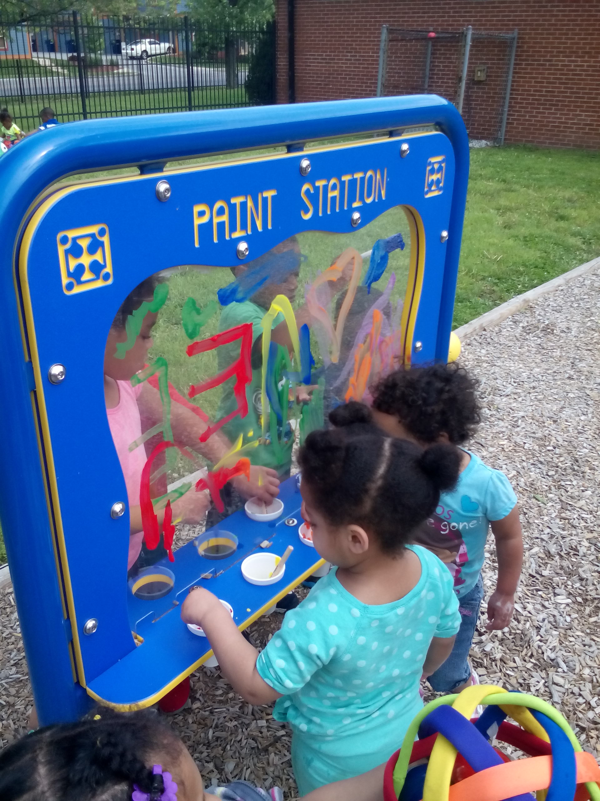

By Shontay Martin
ECED 103 – 1AH
Stages of Art


By Shontay Martin
ECED 103 – 1AH

Theories of Art Development
Theories of Art Development:

(Review each of the “Theories” found in Chapter 5 of Text Book 2)

- Write in your own words
- Properly cite references APA style
- Visit the Writing Center for assistance!!!
- Each Explanation/Theory can be separated as a bulleted item or a separate paragraph
- Should be approximately 2 – 3 pages
- Double spaced
- 12 pt font – Times New Roman/Arial

Cover the following theories:
- Physical Explanation
- Emotional Explanation
- Perceptual Explanation
- Cognitive Explanation
- General Explanation

Disordered & Random
Scribbling
Disordered & Random Scribbling

- Give a detailed description of this stage
- Can be written in paragraph form or bulleted form
- Must be written in your own words
- Include at least 2 – 4 references
- Cite references APA style on this page and on the Reference Page
- Include 4 – 6 samples of children’s art work demonstrating this stage of art right behind this page

Controlled Scribbling
Controlled Scribbling

- Give a detailed description of this stage
- Can be written in paragraph form or bulleted form
- Must be written in your own words
- Include at least 2 – 4 references
- Cite references APA style on this page and on the Reference Page
- Include 4 – 6 samples of children’s art work demonstrating this stage of art right behind this page

Named Scribbling
Named Scribbling

- Give a detailed description of this stage
- Can be written in paragraph form or bulleted form
- Must be written in your own words
- Include at least 2 – 4 references
- Cite references APA style on this page and on the Reference Page
- Include 4 – 6 samples of children’s art work demonstrating this stage of art right behind this page

Preschematic
Preschematic

- Give a detailed description of this stage
- Can be written in paragraph form or bulleted form
- Must be written in your own words
- Include at least 2 – 4 references
- Cite references APA style on this page and on the Reference Page
- Include 4 – 6 samples of children’s art work demonstrating this stage of art right behind this page

Schematic
Schematic

- Give a detailed description of this stage
- Can be written in paragraph form or bulleted form
- Must be written in your own words
- Include at least 2 – 4 references
- Cite references APA style on this page and on the Reference Page
- Include 4 – 6 samples of children’s art work demonstrating this stage of art right behind this page

Drawing or Dawning Realism
Drawing or Dawning Realism

- Give a detailed description of this stage
- Can be written in paragraph form or bulleted form
- Must be written in your own words
- Include at least 2 – 4 references
- Cite references APA style on this page and on the Reference Page
- Include 4 – 6 samples of children’s art work demonstrating this stage of art right behind this page
References
- Cite each reference include in the notebook
- Cite them APA style

