Documentation Panel Report

Documentation Panel Report

ECED 243-00H

Shontay C. Martin

Ivy Tech Community College of Indiana

Scheduled LP ABC Presentation Date & Time

Student’s Name: Shontay Martin

Site Name: A+ Childcare and Preschool Learning Center
Address: 1831 West 16th Street
City: Indianapolis State: Indiana Zip: 46202
Site Phone #:317.671-0028
Site Contact Name: Antwun L. Allen Freeman

LP Concept: Math-Classification
Selected Age Group: 4 and 5 year olds
Scheduled date and time:
Date: Wednesday, April 11, 2018
Time: 9:30am

The lesson concept is mathematic classification. Classification is the process of grouping items together by one or more common characteristics or attributes. For example, grouping by color, size, shape, type, texture, and flavor. Once they have classified items, children can compare items further to learn more specific similarities and differences between items, both within and between matched groups.
This lesson was selected in the efforts to strengthen cognitive skills in the area of language and Mathematics. Early learners develop foundational skills in learning to understand concepts of classification, data collection, organization, and description. After observing and documenting the children in the classroom I quickly was able to identify that the children had little to know exposure to classifying and sorting, however was familiar with the term matching. They were all excited about exploring something new. Because the children understood about matching we were able to build from their prior knowledge of matching. In the lesson plan, the children are able to classify with two different color sticks, sorting them into baskets. If some were able to sort, match or classify using two color sticks, they were able to progress to sorting with three colors sticks.
I was able to visit A Plus Early Learn Center to assess the children in the preschool classroom. During this time I was able to observe the classroom schedule, some of the classroom activities and centers, and observe the children. The children were very engaged in an activity they were doing called folder buddies. The folder buddies were like a matching game. I noticed there was a great interested in this activity yet there were only six folders for the children to explore. To support, expand and scaffold the child’s knowledge I chose to do the activity that incorporated classifying. Because the children had some experience with matching I decided to use some of the everyday items they see around their class. It is very important to choose an activity that is developmentally appropriate for each child that will help build their cognitive development. I choose a hands-on activity that allows children to be actively engaged in their learning.
It was important to me that I understood how to explain the difference between sorting and matching and how to explain such a big word “Classify” to children. To get a better understanding myself I looked to (The Free Dictionary). I researched on the internet mathematics/classification through NAEYC and it gave me insight on how to help children understand sorting and how to make math fun (Math is Fun, 2018). From my prior knowledge of working with children, I have found that children work best when they are actively engaged in what they are learning. Children learn through hands-on interactions which helped my choice in how to present this lesson.

References:

Classify. Math is Fun online dictionary. Retrieved February 14, 2018
https://www.mathsisfun.com/definitions/classify.html

Retrieved February 14, 2018, from
https://www.themeasuredmom.com/math-with-counting-bears/

Indiana Department of Education and Family and Social Services Administration. Division of Family Resources, Bureau of Child Care. Foundation to the Indiana Academic Standards for Young Children from Birth to Age 5. Retrieved from
http://www.doe.in.gov/sites/default/files/earlylearning/foundations-2015-august-12.pdf

We used two different color objects (sticks) that were the same size and length to classify into two separate baskets. I determined that the use of everyday art supplies would give the children a better visual of what looks different can also be the same.
When I arrived the teacher already had the children broken into centers. I had four children at my table waiting on me. To introduce the concept/lesson I displayed a large Ziploc baggie that had yellow and green sticks that were all mixed up in it. I asked the children “Can you help me get my sort/match my sticks?” and “What do you think we could sort/match them in?” The children were all to eggier to help me get my sticks in order.
I asked the children lots of questions and got the following answers.
“What’s in Ms. Shontay’s bag?”
Terry, DaMani, Axle, Kaydain- “Sticks”

“How can I get them to match?”
Terry- “we don’t know how”
DaMani-“ put them on the table”
Axle-“match them together like what”
Kaydain-“show me”

“What are these two colors?”
Terry, DaMani, Axle, Kaydain-“Yellow and Green”

“What makes them the same?”
Terry, “They can make a T”
DaMani, “They are tall”
Axle, “Sticks, they sticks”
Kaydain-“They are both long”

“What makes them different?”
Terry, -“the colors”
DeMani, -“yeah one is red”
Axle, -“one is red and one is green”
Kaydain-“I don’t know what is different”

“Where do you think we should put the sticks?”
DaMani-“On the table”
Axel- “in those white baskets”
Kaydian- “I think we can stack them”
Terry “in the baskets Ms. Shontay”

“How many baskets do you think we would need?”
Axel- “2 baskets”
Kaydian- “yes I think 2 baskets”

“Which colors are going in which basket?”
DaMani-“yellow goes in here and green in here”
Axel- “yellow in one and green in one”
Kaydian- “one yellow one green”
Terry “yellow and green, yellow and green”

When the children caught on and were able to meet their BO I advanced the lesson by adding a new color.
“What is this new color we are adding?”
Terry, DaMani, Axle, Kaydain-“Red”

“Where are we going to put the red sticks?”
DaMani-“we need another basket”
Axel- “we need three baskets”
Kaydian- “I only need two”
Terry “I can share with DaMani”

Entire Documentation Panel

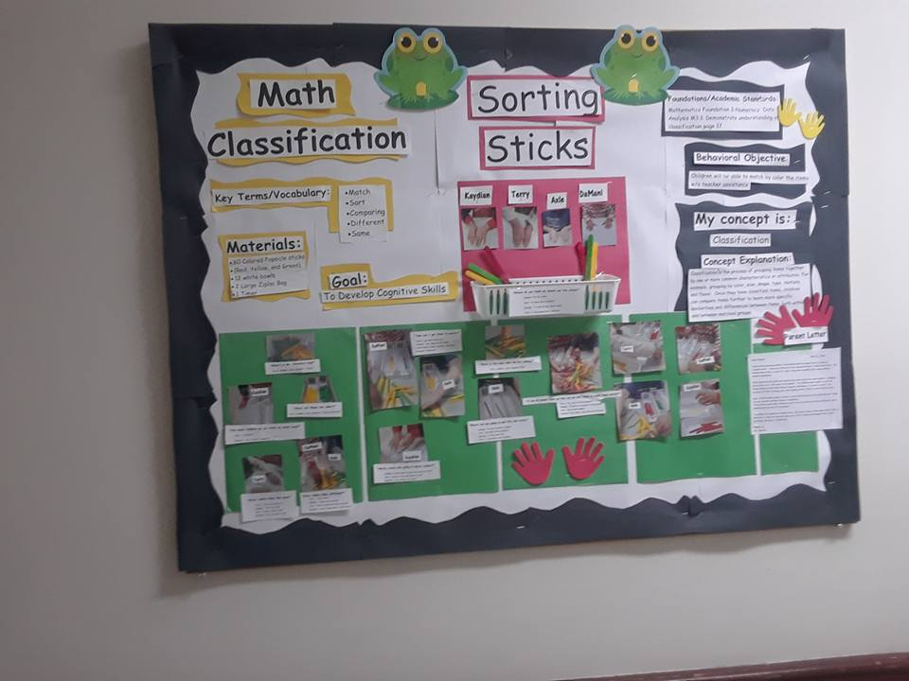

Cognitive Lesson Plan Form

Sorting Sticks
“Math-Classification”

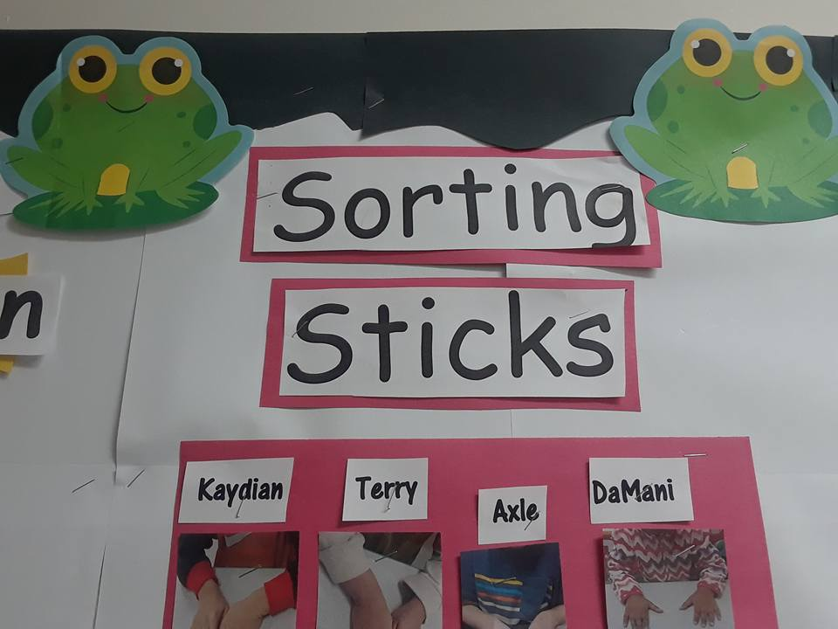

Goal, Key Vocabulary List and Materials
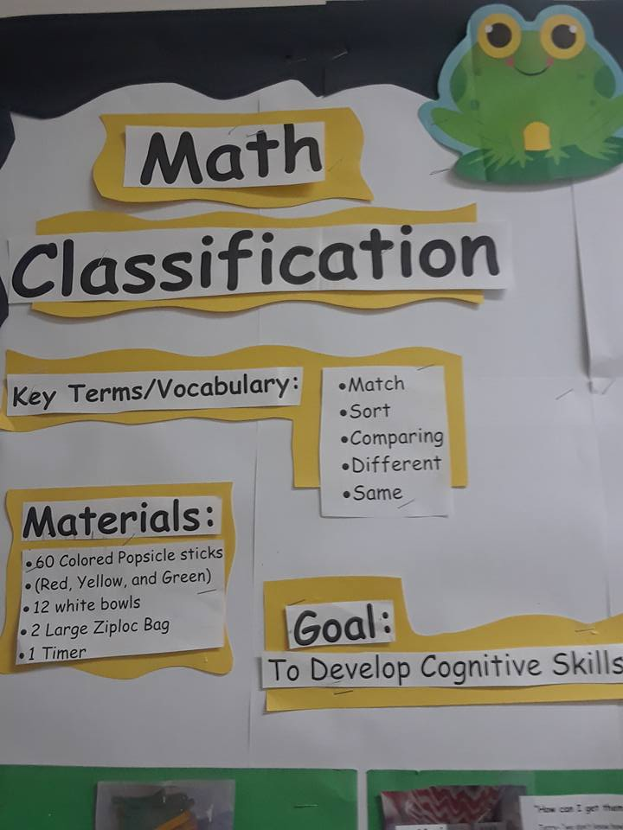

Foundation and Behavioral Objective

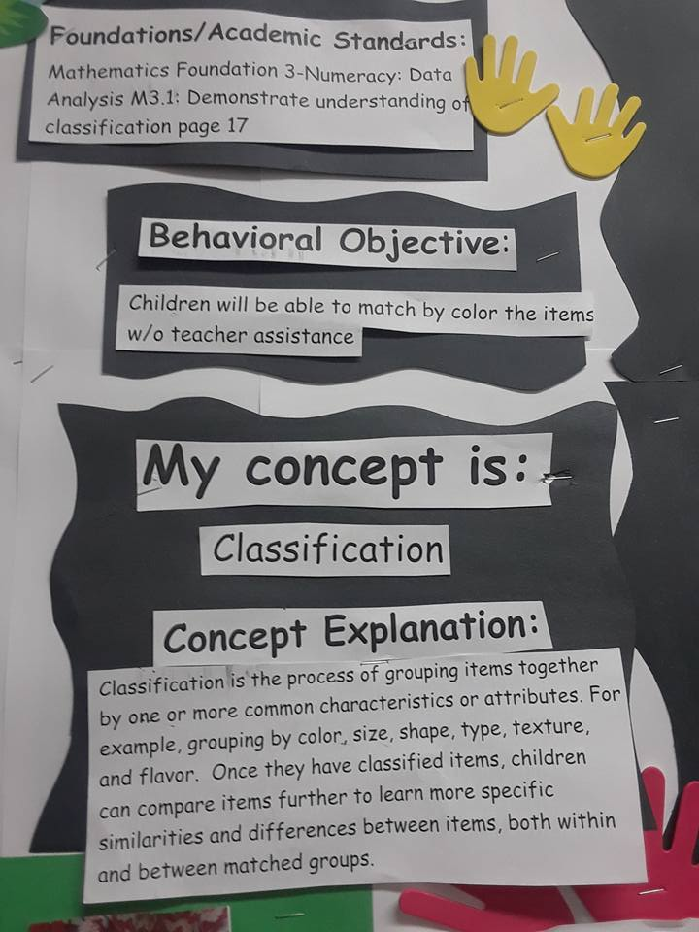

Children Working on the Lesson

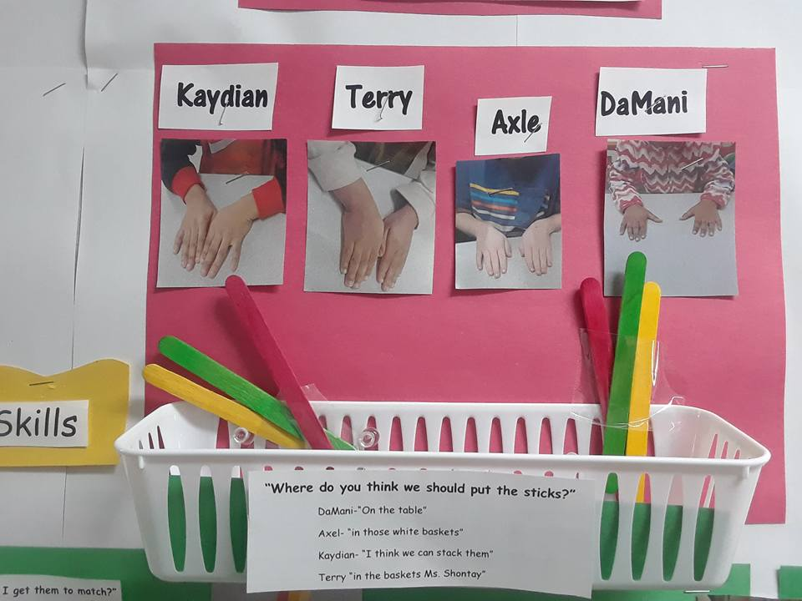

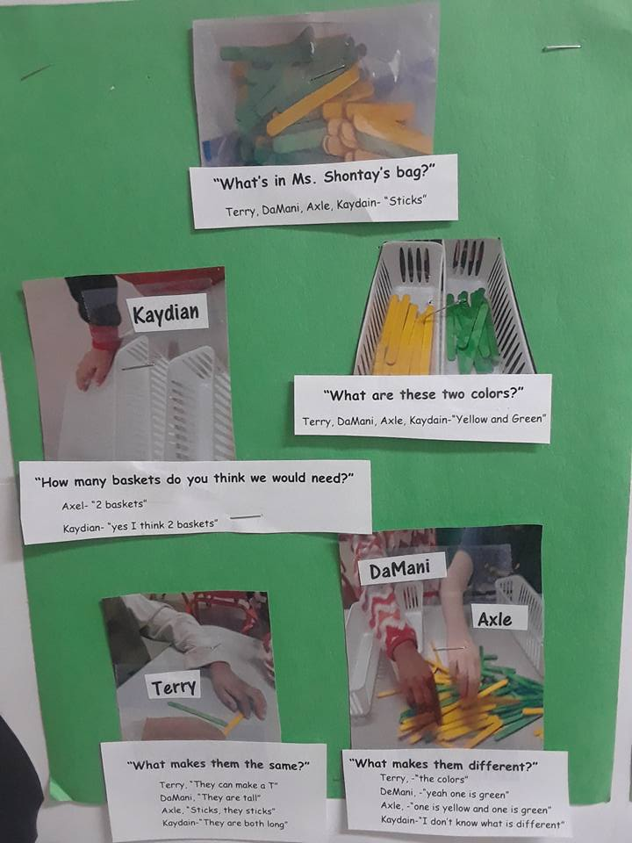

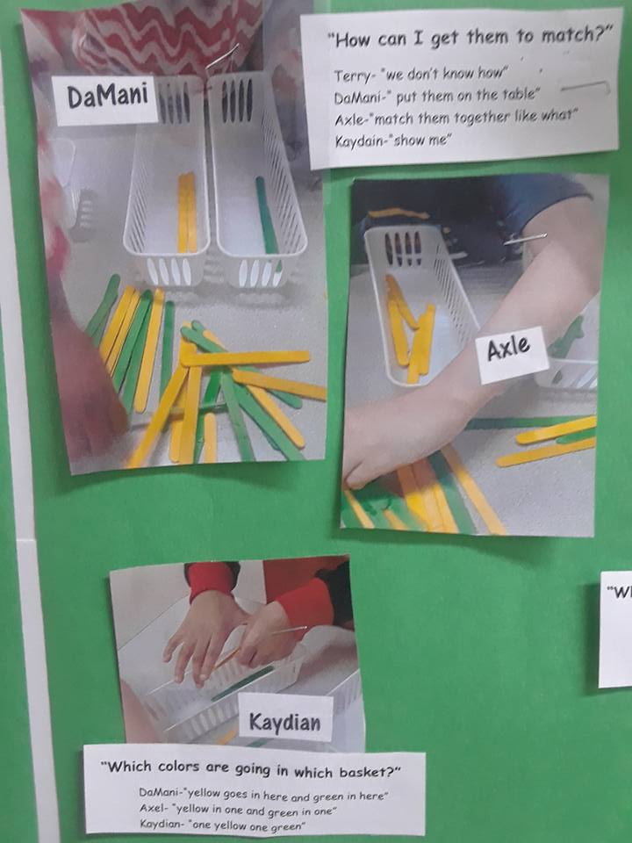

Added a New Color to Sort
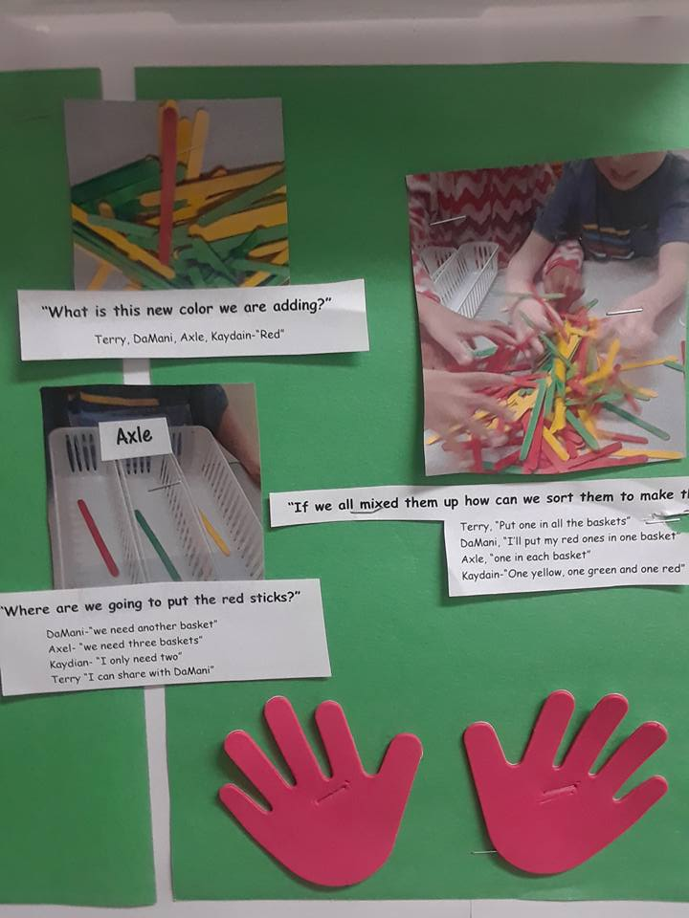

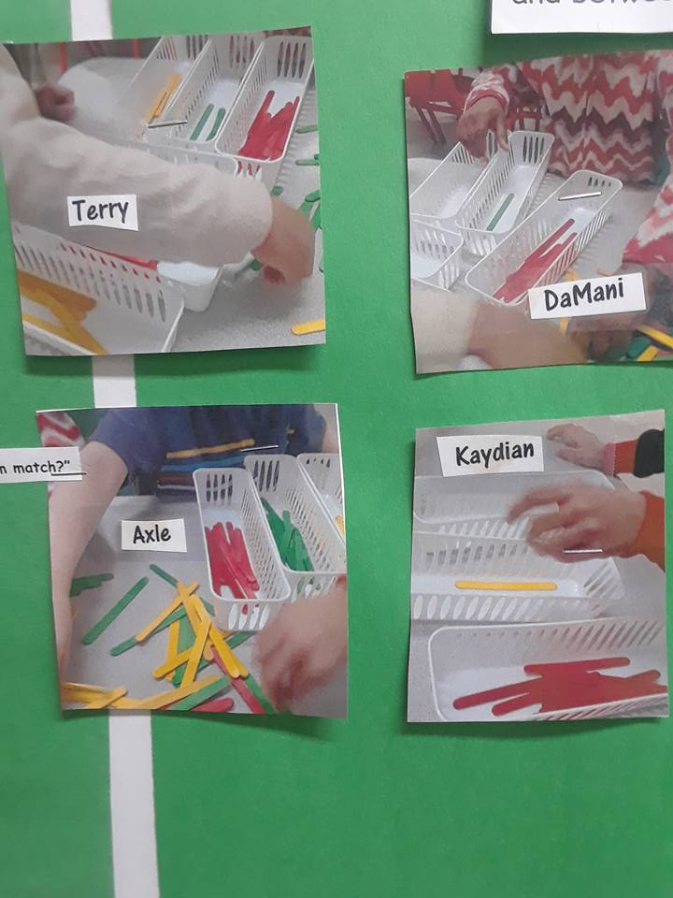

What Did We Learn?
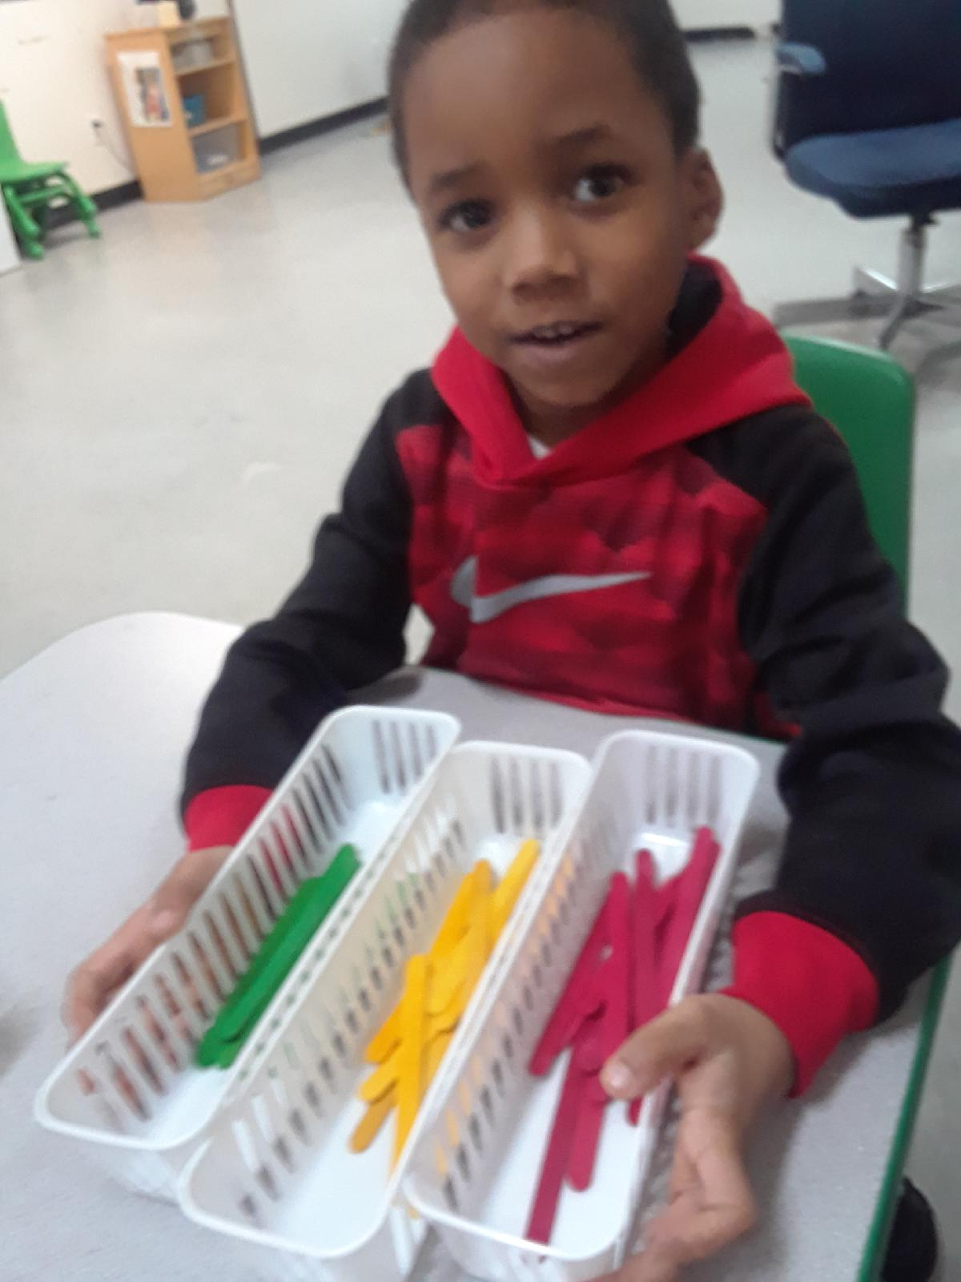
Kaydian-

“I can match the colors, I can sort them all out by myself”

DaMani-

“I know some are the same and different and I can match them up in a basket by theyself”

Axel-
“Ms. Shontay I know how to sort them so they match all the same” I have red, green and yellow in their own basket”

Terry-
“They are all the same sticks but they are all a different color”

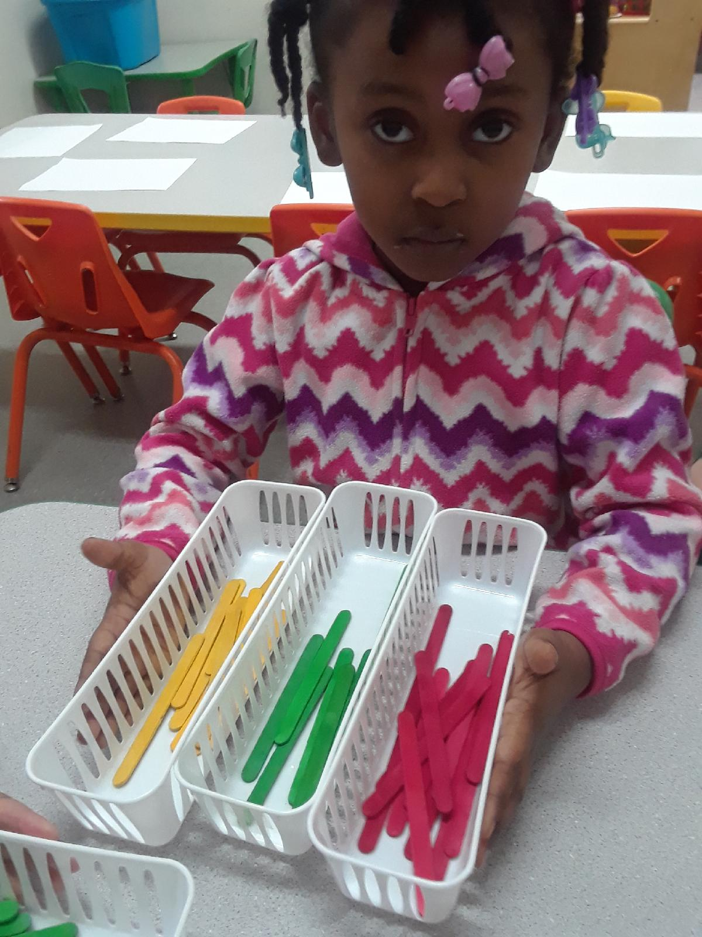

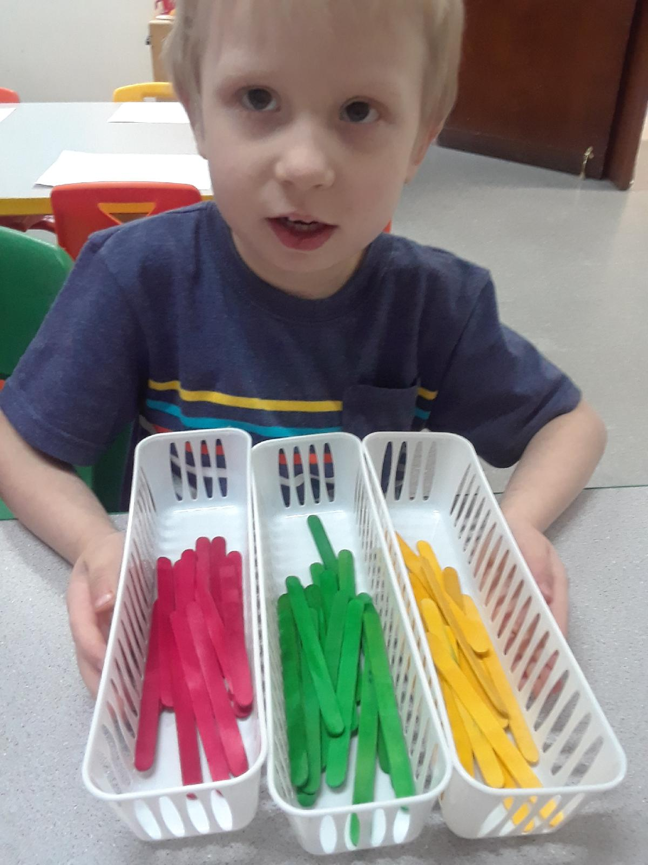

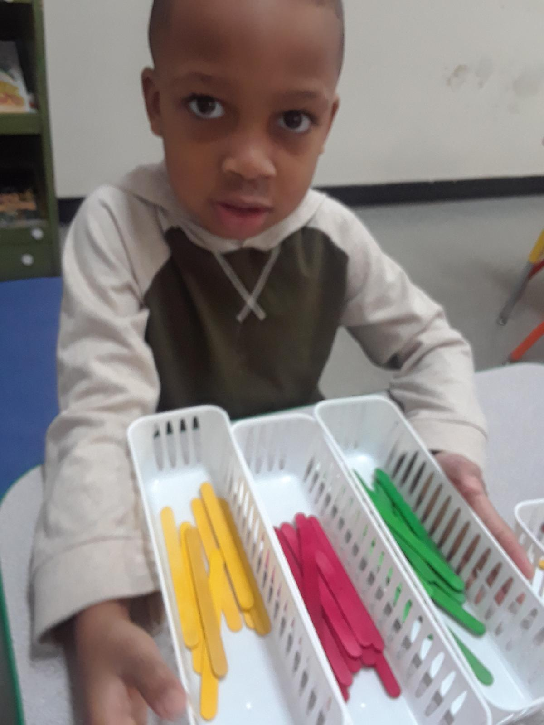

Section A:

Name: Shontay Martin

Lesson Name: Math Classification

Age Group: 4-5 year olds #Of Children: 4 Duration: 15-20 Minutes

Curriculum Area:

___X__ Math _____ Science _____ Social Studies

Developmental Areas:

__X___ Social ___X___ Emotional __X__ Cognitive

___X__ Physical __X__ Language __X___ Creative

Goal: To Develop Cognitive Skills

My concept is: Classification

Concept Explanation:

Classification is the process of grouping items together by one or more common characteristics or attributes. For example, grouping by color, size, shape, type, texture, and flavor. Once they have classified items, children can compare items further to learn more specific similarities and differences between items, both within and between matched groups.

References:

Classify. Math is Fun online dictionary. Retrieved February 14, 2018 https://www.mathsisfun.com/definitions/classify.html

Retrieved February 14, 2018, from https://funlearningideas.com/11-correspondence-preschool-sensory-activities/

Retrieved February 14, 2018, from https://funlearningideas.com/11-correspondence-preschool-sensory-activities/

Retrieved February 14, 2018, from https://www.themeasuredmom.com/math-with-counting-bears/

Section B:

Behavioral Objective:

Children will be able to match by color the items w/o teacher assistance

Foundations/Academic Standards:

Mathematics Foundation 3-Numeracy: Data Analysis M3.1: Demonstrate understanding of classification page 17

Materials:

60 Colored Popsicle sticks (Red, Yellow, and Green)
12 white bowls
2 Large Ziploc Bag
1 Timer

Transition / Introduction to Lesson:
The preschool teacher has agree to already have the children broken down into centers. I will have a table of 4 eager students at a time. I will introduce the lesson by starting with “Look at my bag of colored sticks, they are all mixed up, can you help me sort them?
” I have two different color sticks in my bag red ones and blue ones, are they the same? What make them the same? What makes them different? I have two baskets what color do you think we should put in the first one? What color do you think we should put in the other one?

Section C:

Procedures Of Lesson Listed Step By Step:

- Preparation for the Lesson:
  - Gather needed materials: 12 white baskets, 60 colored sticks and 2 large Ziploc bag to put all the sticks in. Red and blue will be the sticks we use in the beginning and we will add yellow from the other bag as the children catches on to the concept

- Introduction of the Concept:
  - I will start with a question “I have a bag with two different colored sticks, they are all mixed up, can you help me sort them out and put them in the proper basket?”

- Behavioral Objective:
  - The child will be able match by color the items w/o teachers assistance

- Assessment of the Behavioral Objective:
  - To determine the extent to which the children have met the BO I will observe the child as they match the match the sticks in the baskets according to the color

- Wrap up of Lesson:
To bring the lesson to a close
- “What would happen if we all dumped them back in the bag?”
- After the children mix them up again in the bag a warning 3 minute timer will be set to let the children know that their time is coming to an end.
- “What do you think matching mean?”

- Clean Up:
  - The children will take all the yellow stick and put them in a bag and mix the red and blue ones up in a separate bag

Classroom Management Note:
- Allow the other children to have center time
- Make sure you are sitting near the groups to assist while teaching the lesson

Key Terms/Vocabulary:
- Match
- Sort
- Comparing
- Different
- Same

Open Ended Questions:
- “What are these two colors?”
- “What makes them the same?”
- “What makes them different?”
- “Where do you think we should put the sticks?”
- “What is this new color we are adding?”
- “How is the same or different from the other two colors?”

Where to Go From Here:
Children that were met their behavioral objective
- Add more colors to classify
- Add more attributes to classify

Children that had difficulty meeting their behavioral objective
- Allow more time to practice classifying two objects at a time
- Change the two objects used

Follow Up/Enrichment or Extensions to Lesson:
  - Make this a part of the lesson
  - Add this table as a learning center
  - Send home items to classify
  - Ask parents to donate items to for a week of classifying fun
Documentation:
- Photos will be taken before during and after the lesson
- Answers to the open ended questions given by the children will be noted
- The children’s overall experience will be noted

