Prop Box

ECD 103
Curriculum Early Childhood Education
Shontay Martin
Ivy Tech Community College of Indiana


Prop Box Written Report


Name Shontay Martin

Theme/Topic “It’s A Birthday Celebration”

Age Group Preschoolers #Children 4-6

List the Contents Below:

___1 – Party plates ___13 – 1 Chair Cover
___2 – Party Hats ___14 – Party Invitations
___3 – 2 Gift Boxes ___15 – Markers
___4 – 2 Large Glasses ___16- Party Gift Bows
___5 – 2 Lg Party Hats ___17- Birthday Cake
___6 – Party Banner ___18- Party Cups
___7 – Party Balloons ___19- 2 Sensory Bottle
___8 – 1 Party Books ___20- Cake Magnets
___9 – Party Napkins ___21- Cupcake Match
___10 –Birthday Song ___22- Match Cup Cake
___11 –Party Necklaces ___23-Birthday Magnets
___12 –Party Center Pieces ___24- Cake Magnet Pan
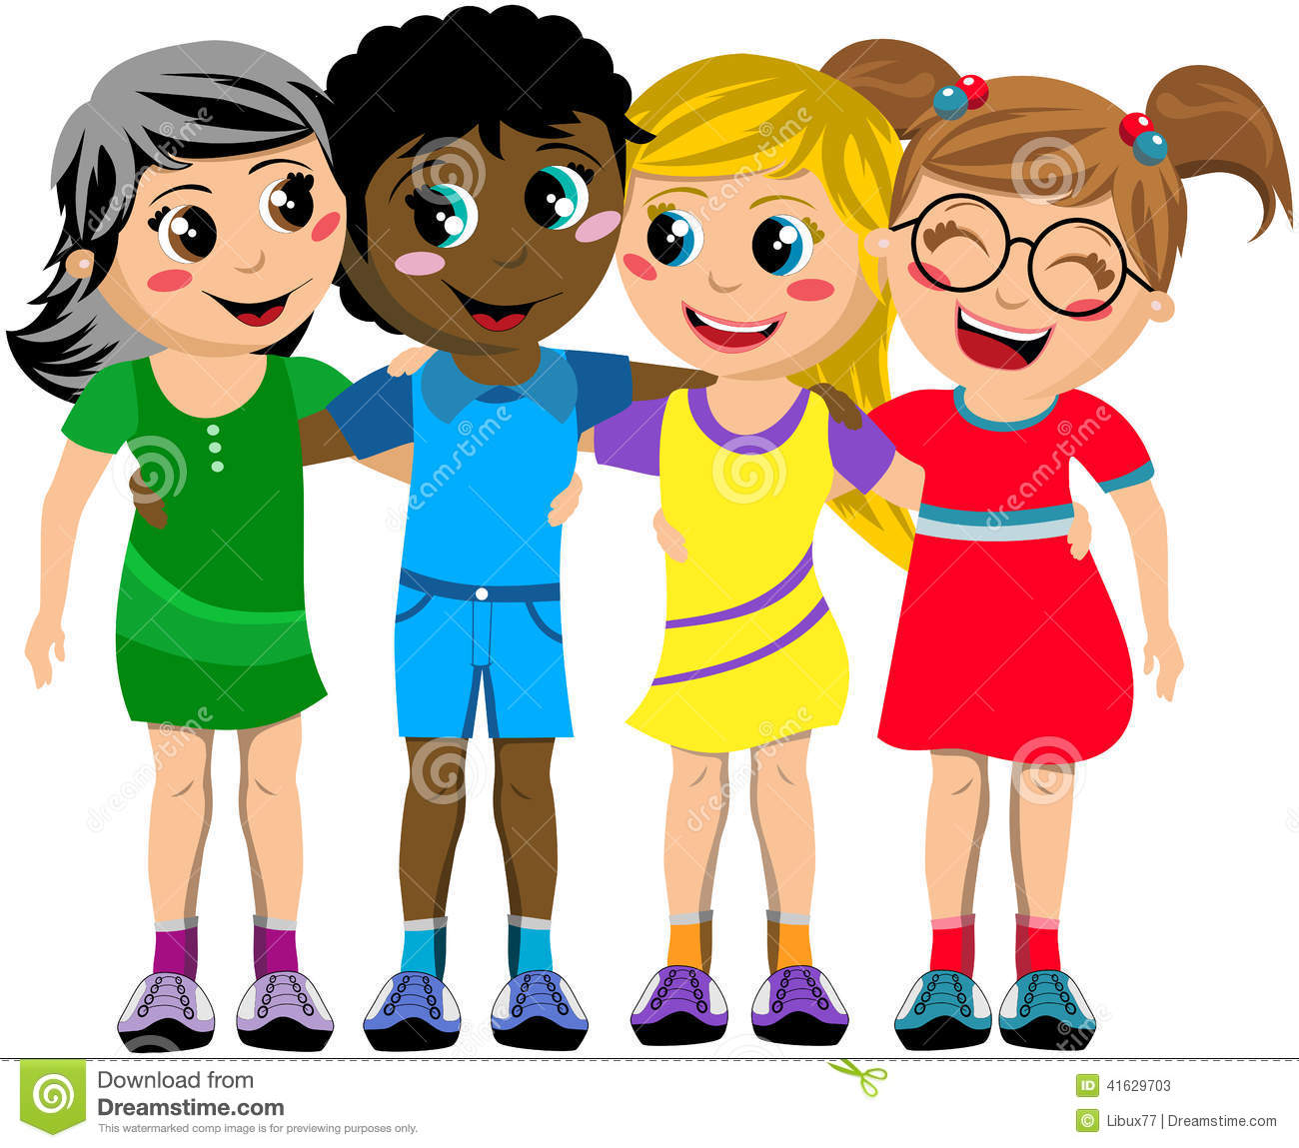

Literacy

- Writing Invitation
- Singing Happy Birthday
- Discussing who to invite to the party
- Cup Cake Match Folder Buddy
- Match the Number to the Cup Cake
- Pretend Party

How Literacy Is Promoted
- Writing Invitation-Encourage early writing skills, written communicating skills and early language skills

- Sensory Bottles- children will use their senses to describe what they see hear and feel.

- Singing Happy Birthday-Promotes language skills

- Discussing who to invite to the party-Promoting comprehension, conversation and cooperative play.

- Cupcake Match Folder Buddy-Promoting cognitive skills, matching, sequencing, comparing colors and objects

- Match the Number to the cupcakes-Promoting writing skills, cognitive skills, counting, compare numbers and objects.

- Pretend Party- Children will be able to use their creativity and imagination in using the materials to create they party that they would like to have.
Wish List of 15 additional items

1 – Folder Buddy Hat Match 9 – Ice Cream Match
2 – Large Buttons 10 – Name and Picture Match
3 – Paint A Cake 11 – Treasure Box w/Key
4 – 5 More Sensory Bottles 12 – Noise Makers
5 – Musical Instruments 13 – Camera
6 – Steamers 14 – Playdough
7 – Thank You Cards 15 – Candles
8 – Pretend Gifts 16 – Alumna foil cake pan

Key Vocabulary:
Pretend Invitation Candles
Birthday Center Piece Foil
Celebration Born Streamers
Event Friends
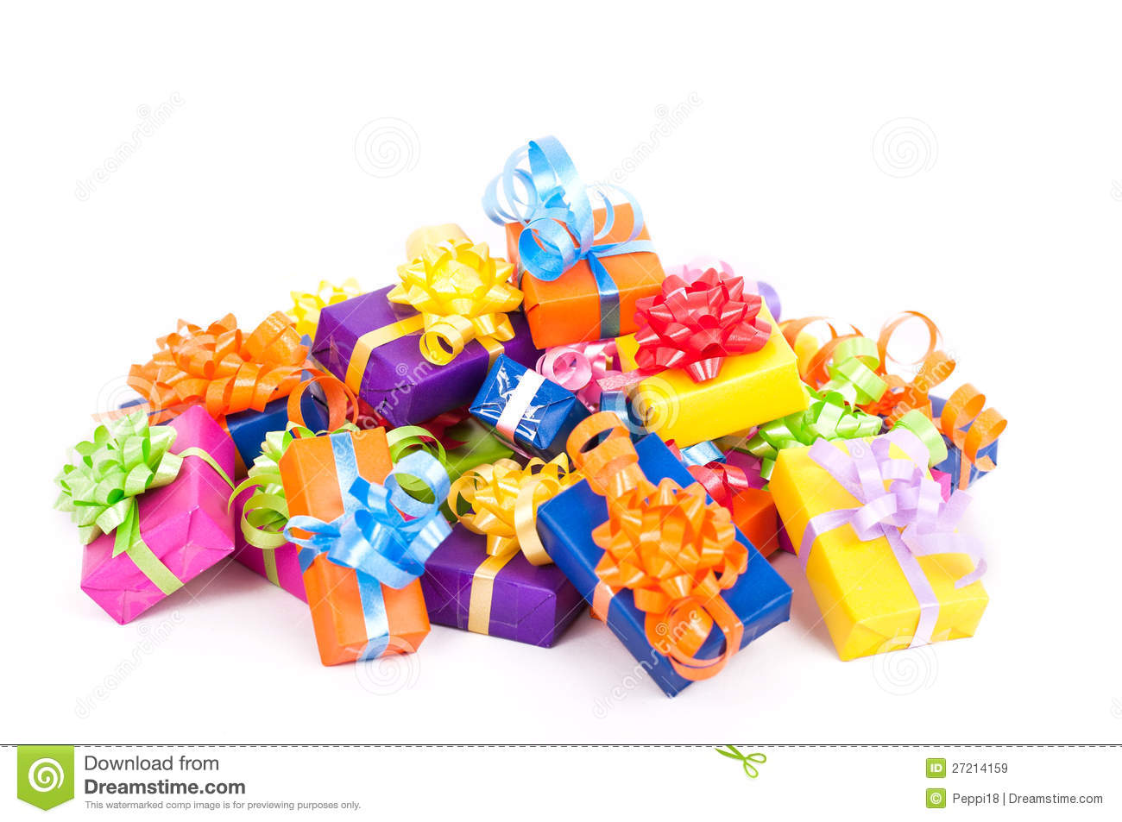
Games Invited
Treat Box Magnet

Teacher’s Role:
Upon introducing the birthday celebration prop box to the children, the teacher must explain the contents of the items in the box, the rules, and how the games played. It is also important to explain the number of children allowed at the celebration at one time.
The first few days of the birthday celebration the teacher should be very hands on and interacting. The first birthday celebration can be the teacher’s. After the first few days have passed and the children seem to have a good sense of how to take turns and share the teacher should be close by to observe the children but not interrupting or giving ideas unless the children ask her.
By the teacher setting a limit of how many children are permitted at the celebration at one time, she is setting the tone indirectly of how the time spent during the celebration will be. The teacher should intervene as little as possible. This intervention will be something as small as saying “its Jimmy’s birthday this time” or “Yes you got them all correct” to stepping in if she sees the children’s disagreement lead to physical inappropriate actions.


